**ASSIGNMENT NO : 1**

**IBM(NALAIYA THIRAN)**

**TEAM MEMBER 2: KAVI ARASU .G**

**REG NO: 510619106010**

**EMAIL: kaviarasu20122001@gmail.com**

**TOPIC : SMART HOME**

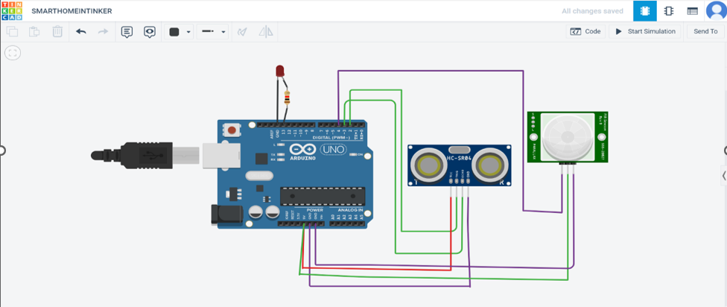

**TINKERCAD**

**CODE:**

int trigger_pin=2;

int echo_pin=3;

int time;

int distance;

void setup()

{

Serial.begin(9600);

pinMode(trigger_pin,OUTPUT);

pinMode(echo_pin,INPUT);

pinMode(4,INPUT);

pinMode(13,OUTPUT);

}

void loop()

{

digitalWrite(trigger_pin,HIGH);

delayMicroseconds(10);

digitalWrite(trigger_pin,LOW);

time=pulseIn(echo_pin,HIGH);

distance=(time*0.034)/2;

if(distance<=10)

{

Serial.println("Door open");

Serial.print("Distance=");

Serial.println(distance);

delay(500);

}

else{

Serial.println("Door closed");

Serial.print("Distance=");

Serial.println(distance);

delay(500);

int p=digitalRead(4);

if(p)

{

digitalWrite(13,HIGH);

Serial.println("motion detected");

}

else

{

digitalWrite(13,LOW);

Serial.println("not detected");

}

}

}